VISTA Seminar

Seminar 1

9:30 – 11:00 am EDT / 1:30 – 3:00 pm GMT

TOC:

1. Presenter 1: Prof. Linjun Wang, Zhejian University, China………… page 2
2. Presenter 2: Mr. Brendan Smith, University at Buffalo, USA………. page 3
3. How to connect……………………………………………………… page 4

Branching Correction for Mixed Quantum-Classical Dynamics

Linjun Wang

Department of Chemistry, Zhejiang University, China

Email: ljwang@zju.edu.cn

**Abstract** In chemistry, physics, biology, and material sciences, many important processes are relevant to nonadiabatic dynamics. Surface hopping and mean field have become the most widely used mixed quantum-classical methods for studying general charge and exciton dynamics. The reliability of surface hopping simulations relies on robust crossing and decoherence corrections.1-4 Recently, we introduced a branching correction to surface hopping, which resets the wavefunction coefficients based on the judgement of wave packet reflection.5 Our method ensures the self-consistency of using the traditional time-dependent Schrödinger equation to describe the mixed quantum-classical dynamics and captures the majority of the decoherence effect as demonstrated in the three standard Tully models (see Figure 1) and over two hundred additional scattering models, surpassing other investigated decoherence correction algorithms. Inspired by the branching correction, we proposed better energy-based decoherence time formulas.6 We further applied a similar branching correction to mean field and achieved about 10-fold improvement of accuracy compared with the widely used Ehrenfest mean field method.7 In fact, the branching corrected mean field and surface hopping methods provide highly reliable and almost identical results using the exact quantum solutions as references in the investigated systems, implying that branching correction is essential in mixed quantum-classical dynamics and shows good potential for application in general nonadiabatic dynamics simulations.



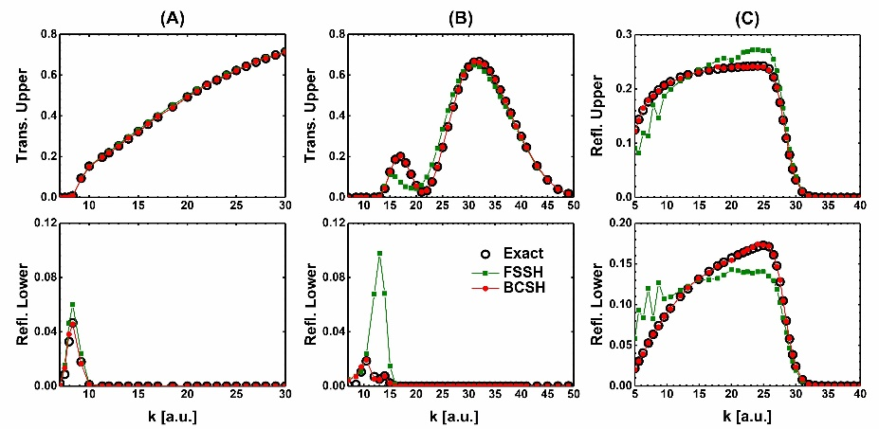

Figure 1. Performance of the fewest switches surface hopping (FSSH) and the branching corrected surface hopping (BCSH) in the three standard Tully models.

**References**

(1) Wang, L.*; Akimov, A.; Prezhdo, O. V.* *J. Phys. Chem. Lett.* *7*, 2100 (**2016**).

(2) Qiu, J.; Bai, X.; Wang, L.* *J. Phys. Chem. Lett.* *9*, 4319 (**2018**).

(3) Qiu, J.; Bai, X.; Wang, L.* *J. Phys. Chem. Lett.* *10*, 637 (**2019**).

(4) Wang, L.*; Qiu, J.; Bai, X.; Xu, *J. WIREs Comput. Mol. Sci.* *10*, e1435 (**2020**).

(5) Xu, J.; Wang, L.* *J. Chem. Phys.* *150*, 164101 (**2019**).

(6) Xiao, B.; Xu, J.; Wang, L.* *DOI:10.1063/1674-0068/cjcp2006098* (**2020**).

(7) Xu, J.; Wang, L.* [*DOI: 10.26434/chemrxiv.12820238*](http://dx.doi.org/10.26434/chemrxiv.12820238) (**2020**).

**Hot Electron Cooling in Silicon Nanoclusters via Landau-Zener Non-Adiabatic Molecular Dynamics: Size Dependence and Role of Surface Termination**

Brendan Smith

Department of Chemistry, SUNY Buffalo, USA

Email: bsmith24@buffalo.edu

**Abstract** In this seminar, I will describe a new express methodology for modeling excited states dynamics in large nanoscale and condensed phase systems in which the explicit computation of nonadiabatic couplings is not required. The method leverages a recent reformulation of Landau-Zener nonadiabatic transition probabilities within the computational efficient Neglect-of-Back-Reaction Approximation. Compared to popular wavefunction-based nonadiabatic molecular dynamics methods within the Neglect-of-Back-Reaction Approximation, our newly developed method is roughly an order of magnitude cheaper and costs only a little more than that of the molecular dynamics. The method is applied to modelling the non-radiative hot electron cooling in hydrogen and fluorine terminated silicon nanocrystals containing up to nearly 600 atoms. We find that hot electrons cool significantly slower in fluorine terminated silicon nanocrystals then their hydrogen terminated counterparts. The slower dynamics in the case of fluorine terminated silicon nanocrystals is rationalized by the larger energy gaps and larger mass of the fluorine atoms. We observe that the dynamics obtained using our new method yields the same qualitative picture as does the popular wavefunction based approach within the Neglect-of-Back-Reaction Approximation. Therefore, we consider the method to be a computationally efficient alternative to obtaining the nonadiabatic dynamics in large nanoscale materials, which is important to the prediction and characterization of their photophysical properties.



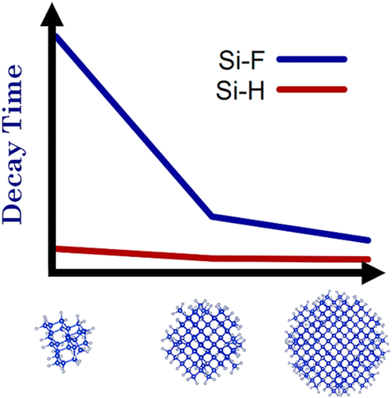

**References**

(1) Smith, B.; Akimov, A. V. "Hot Electron Cooling in Silicon Nanoclusters via Landau-Zener Non-Adiabatic Molecular Dynamics: Size Dependence and Role of Surface Termination" *J. Phys. Chem. Lett.* **2020,** 11, 1456-1465

**How to connect**

Alexey Akimov is inviting you to a scheduled Zoom meeting.

Topic: VISTA

Time: Sep 10, 2020 09:30 AM Eastern Time (US and Canada)

Join Zoom Meeting

https://buffalo.zoom.us/j/91844565900?pwd=cXZjMk5qWkp3L2xOZVZ0ZXRORWZLUT09

Meeting ID: 918 4456 5900

Passcode: 215790

One tap mobile

+16465588656,,91844565900# US (New York)

+13017158592,,91844565900# US (Germantown)

Dial by your location

+1 646 558 8656 US (New York)

+1 301 715 8592 US (Germantown)

+1 312 626 6799 US (Chicago)

+1 253 215 8782 US (Tacoma)

+1 346 248 7799 US (Houston)

+1 669 900 9128 US (San Jose)

Meeting ID: 918 4456 5900

Find your local number: https://buffalo.zoom.us/u/acwuvDh1t8

Join by SIP

91844565900@zoomcrc.com

Join by H.323

162.255.37.11 (US West)

162.255.36.11 (US East)

221.122.88.195 (China)

115.114.131.7 (India Mumbai)

115.114.115.7 (India Hyderabad)

213.19.144.110 (Amsterdam Netherlands)

213.244.140.110 (Germany)

103.122.166.55 (Australia)

209.9.211.110 (Hong Kong SAR)

149.137.40.110 (Singapore)

64.211.144.160 (Brazil)

69.174.57.160 (Canada)

207.226.132.110 (Japan)

Meeting ID: 918 4456 5900

Passcode: 215790